POI Output of the se bucket

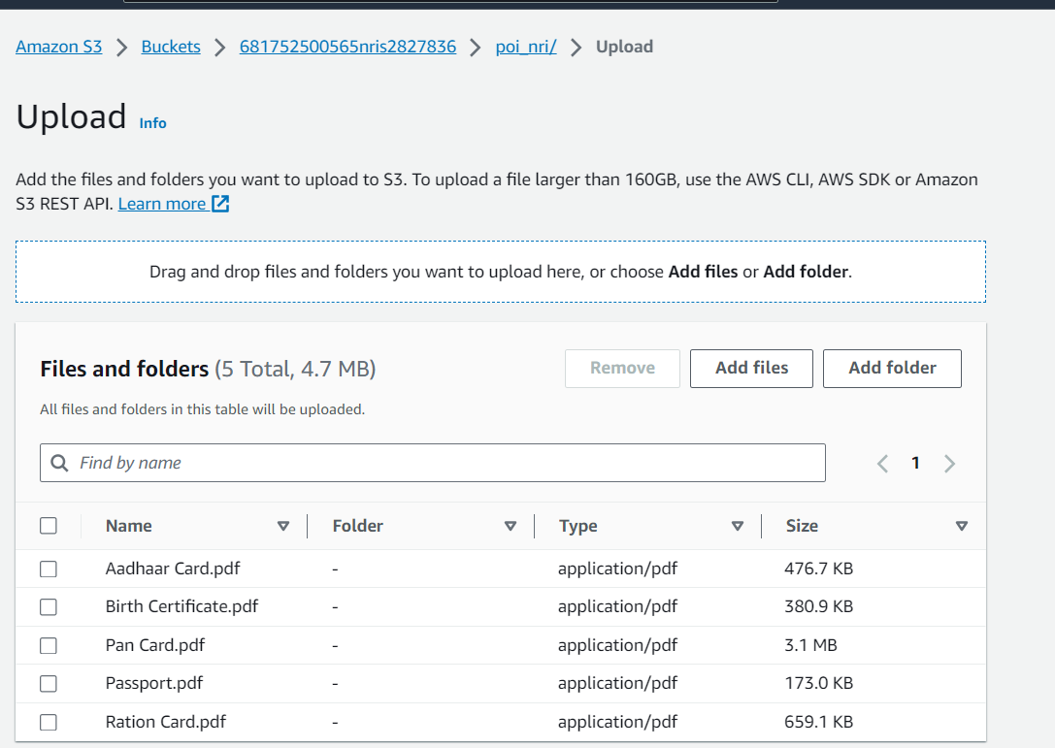

Storage Class: -

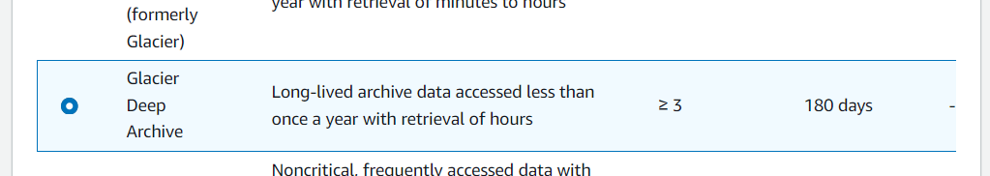

Meta Data: -

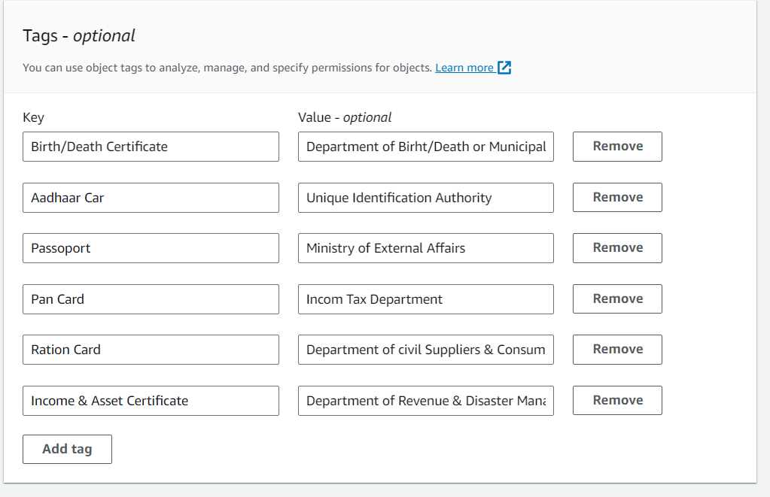

POA Mutal Docs: -

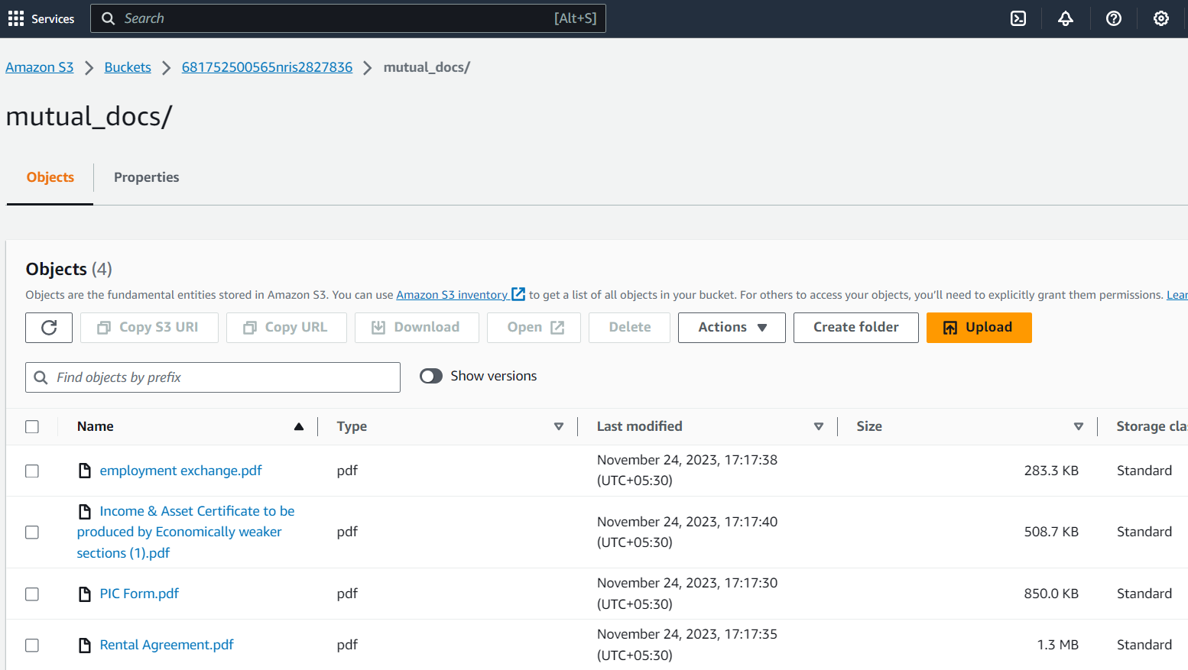

POI Docs: -

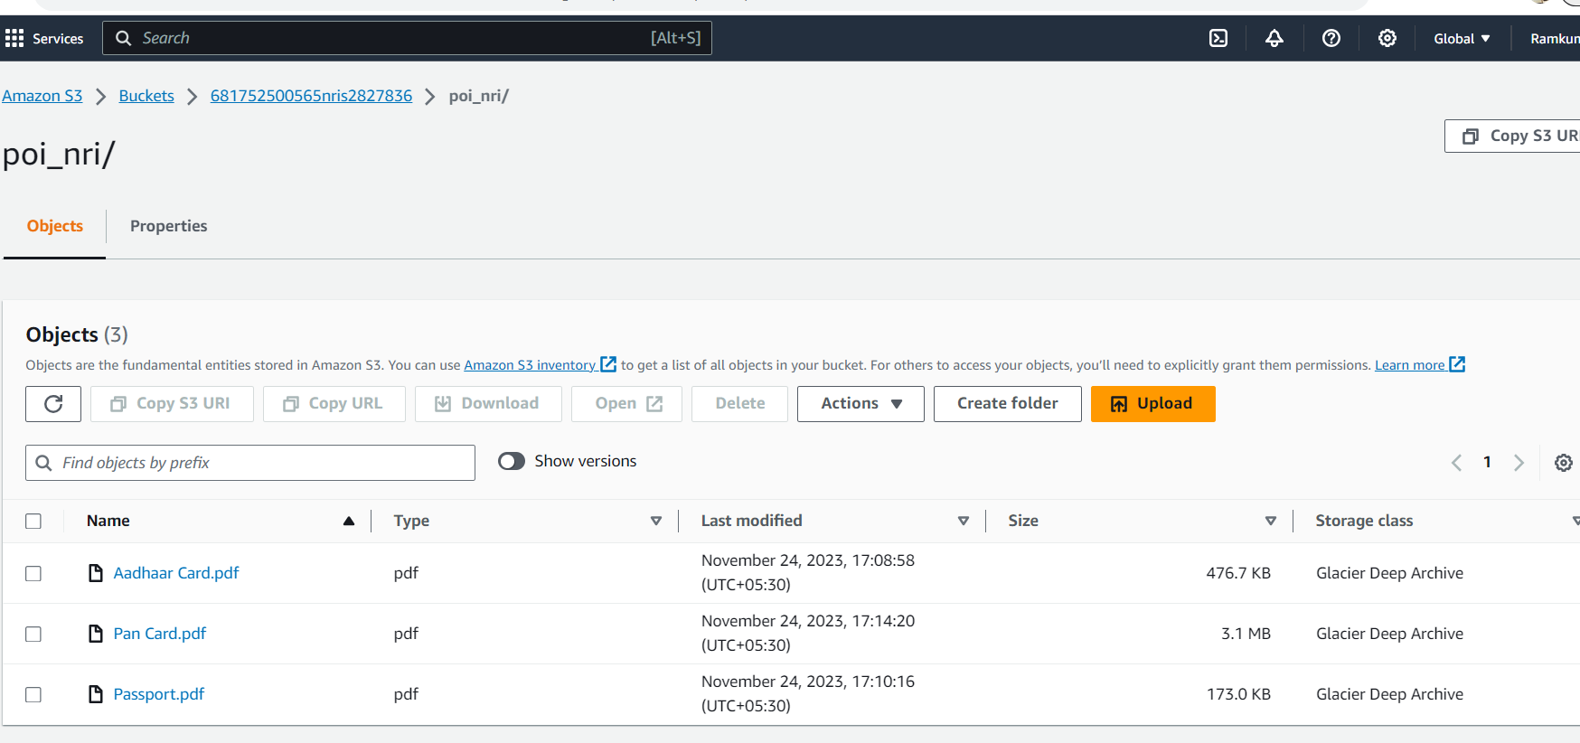

Academy Tracker docs: -

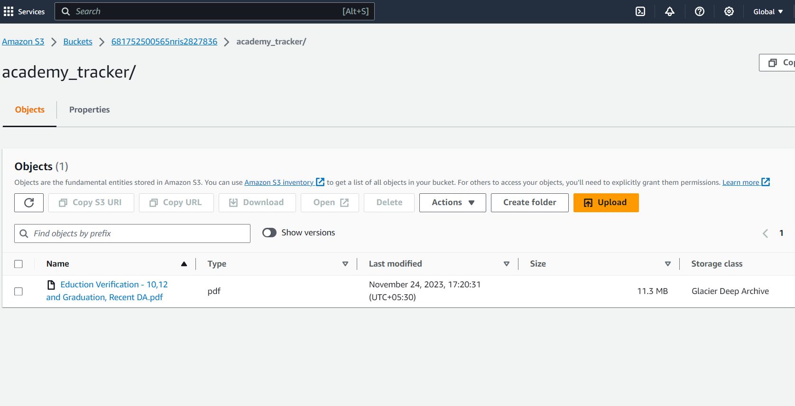

Bucket Syntax Format

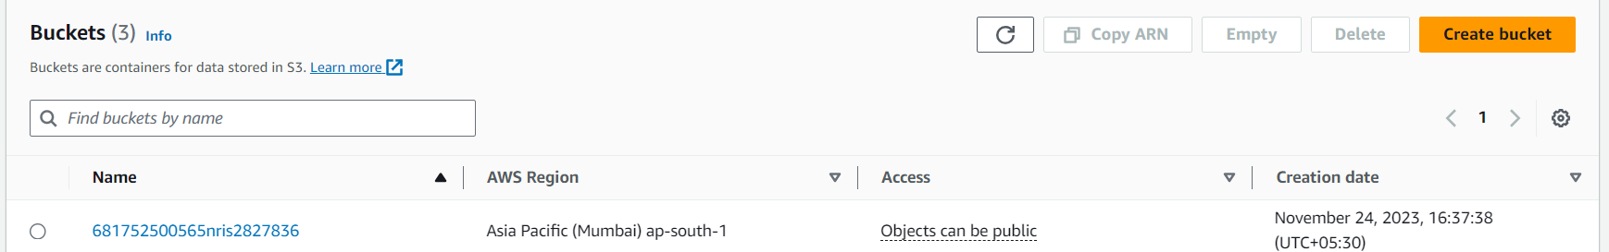

1.<Aadhaarnumnberpassportnumber> -🡪NRI

2.<Aadhaarnumber> -🡪Non NRI